Romans Chapter 8
Blessings From Being a Child of God!
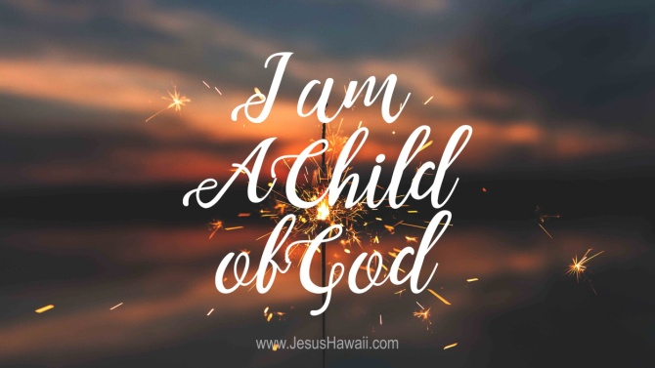
Many Bible scholars consider Romans chapter 8 as perhaps the greatest chapter in the Bible (it’s at least one of the most important). In this chapter we learn many important privileges and blessings from being a part of God’s family – a child of God!

Blessings From Being a Child of God

- No condemnation! Our sin penalty has been covered by Jesus! (v. 1-4)
- Our sinful nature does not have to control us, but we can be controlled by the Holy Spirit (v. 5-9)
- The Holy Spirit lives within us! (v. 9-10)
- Jesus lives within us! (v. 9-10)
- Our bodies will die, but our spirits live on! (v. 10)
- We will have eternal, resurrected bodies! (v. 11, 23)
- We are God’s children, part of His family! (v. 14-17) (See John 1:12; Gal 3:26-29; I John 3:1-3)
- We are heirs of God and co-heirs with Christ! (v. 17)
- Our present sufferings are nothing compared to our future glory! (v. 17-18)
- We have a future glory coming that all creation is looking forward to! (v. 18-23)
- We have the great hope of eternal life! (v. 23-25)
- The Holy Spirit helps us in our weakness, can help us pray, and intercedes for us! (v. 26-27)
- God works all things out for our eventual good! (v. 28)
- God has called us and is helping us to become more like Jesus! (v. 29-30)
- God is for us, and no charge against us will stand! He has our backs! (v. 31-34)
- Jesus intercedes for us! (v. 34)
- We are more than conquerors through Jesus who loves us! (v. 37)
- NOTHING can separate us from the love of God found in Christ Jesus our Lord! (v. 38-39) (See John 10:27-30)
- Other?

predestined - predetermined; note carefully in v. 29 that it is based upon "foreknowledge" (cf. 1Pe 1:2), and that which is predetermined is WHAT those in Christ are to become, not WHO are to be in Christ
ANOTHER MORE TRADITIONAL OUTLINE:

I. IN CHRIST THERE IS FREEDOM FROM SIN (1-17)

A. FREEDOM FROM THE CONDEMNATION OF SIN (1-4)
1. Available to those in Christ, made possible by the law of the
Spirit of life (1-2)
2. An accomplishment not attained by the Law, but by the death of
Christ (3-4)

B. FREEDOM FROM THE POWER OF SIN (5-17)
1. To those who set their minds on the things of the Spirit, not
the flesh, pleasing God (5-8)
2. To those who have the indwelling Holy Spirit (9-11)
3. To those who by the Spirit put to death the deeds of the body
(12-13)
4. To those thus led, who are the children of God and joint heirs
with Christ (14-17)

II. BLESSINGS OF BEING CHILDREN OF GOD (18-39)

A. THE GLORY TO BE REVEALED IN US (18-25)
1. Present sufferings don't even compare (18)
2. The whole creation eagerly awaits for the revealing and
glorious liberty of the children of God (19-22)
3. We also eagerly await with perseverance for this hope (23-25)

B. THE HELP OF THE HOLY SPIRIT (26-27)
1. Helps in our weakness as we pray (26a)
2. By interceding for us as we pray (26b-27)

C. ALL THINGS WORKING TOGETHER FOR GOOD (28-30)
1. For those who love God, called according to His purpose (28)
2. For such, whom God foreknew, He will carry out His ultimate
purpose (29-30)

D. GOD'S LOVE TOWARD HIS CHILDREN (31-39)
1. God, who spared not His own Son, is on our side (31-33)
2. Christ, who died for us, now intercedes for us at God's right
hand (34)
3. Through such love we are more than conquerors over all things
(35-39)

