“Jesus – the Ultimate BFF!”
(BFF = Best Friend Forever)

Following are some important teachings about Jesus, and His relationship with us. The Bible tells us:

1) We All Need Friends!

Ecclesiastes 4:9-12 “Two are better than one, because they have a good return for their work: if one falls down, his friend can help him up. But pity the man who falls and has no one to help him up! Also, if two lie down together, they will keep warm. But how can one keep warm alone? Though one may be overpowered, two can defend themselves. A cord of three strands is not quickly broken”.

2) Some Best Friends Have Different Backgrounds.

Jesus = Supreme in all the Universe!

From Colossians 1:15-20

• Jesus is God and has all God’s fullness!
• Jesus is the “first born” (honored over all creation) and is before all things (supreme)! He was the first to rise from the dead with a resurrected body.
• Jesus is the creator!
• Jesus is the sustainer (holds all things together)!
• Jesus is the head of the church!
• Jesus is the reconciler between God and us!
• Jesus is perfectly Holy, Sinless and Good!

Me (and You) = Sinners (not perfectly Holy, Sinless and Good )

YET

Jesus was called the “friend of sinners” by those wishing to demean Him. But Jesus gladly wore that label! (Matthew 11:19, 9:9-13; Mark 2:13-17; Luke 5:27-32, 15:1-10). Jesus came to save and have a friendship relationship with sinners like me – and you (Luke 19:10; John 3:16-17).

3) Jesus is the Ultimate BFF (Best Friend Forever)! He is the very best friend a person could ever hope for. Why?

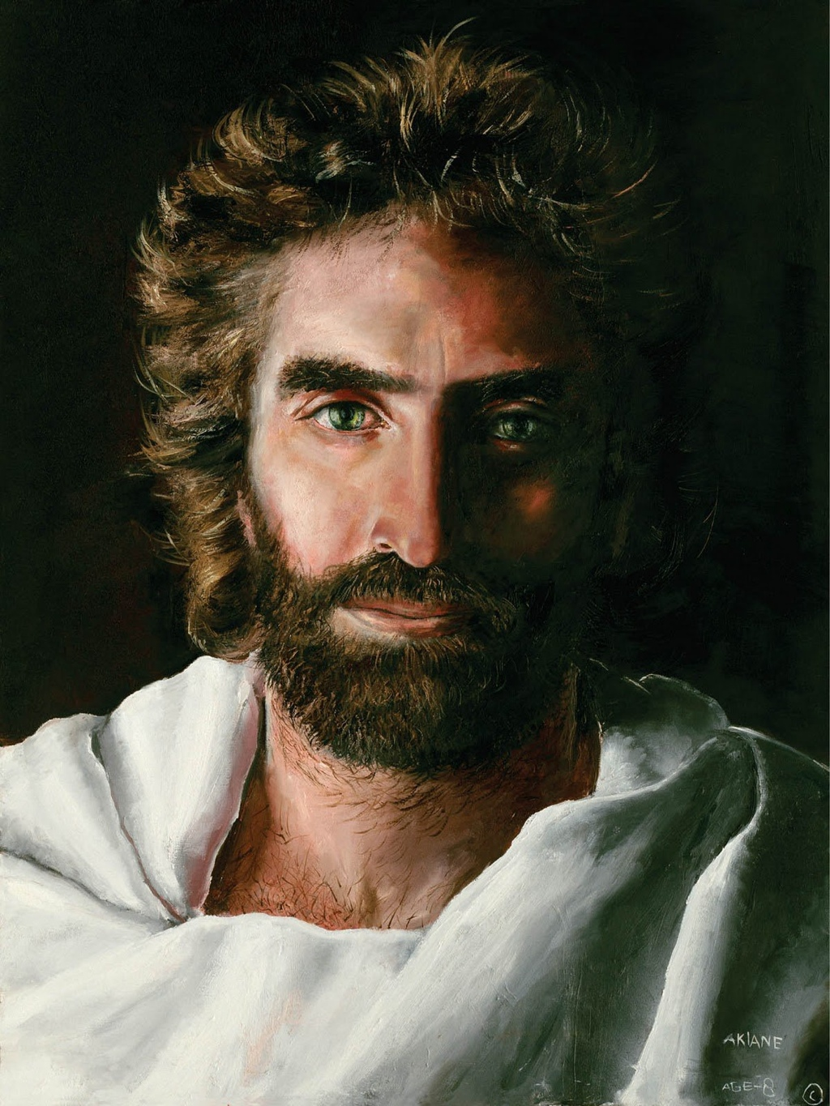

Jesus is the loving, caring, compassionate and understanding “Son of Man” (Jesus is human)

AND

Jesus is also the all-knowing, always present and all-powerful “Son of God” (Jesus is God)

CASE STUDY: Story of Jesus and Lazarus in John chapter 11.
In this story we clearly see the humanity and also the divinity of Jesus in action.

Notes from John Chapter 11:

4) How do we start a personal friendship relationship with Jesus?

Realize that Jesus loves us greatly – and wants a personal relationship with us and it brings Him pleasure! (Ephesians 1:3-5, 2:4) And Jesus loves us and desires a relationship with us so much that He humbled Himself and came to earth to pay our sin debt (Philippians 2:5-11) - and offers us the FREE gift of salvation!

- Romans 3:23 “For all have sinned and fall short of the glory of God”

- Romans 6:23 “For the wages (consequences) of sin is death, BUT the gift of God is eternal life through Jesus Christ our Lord”

- Ephesians 2:8-9: “For it is by grace (undeserved favor) that you have been saved through faith – and this is not from yourselves, it is the gift of God - not by works, so that no one can boast”

- II Corinthians 5:21 “God made Him (Jesus) who had no sin to be sin for us, so that in Him we might become the righteousness of God”

- John 1:12 “… to all who received Him (Jesus), to those that believe in His name, He gave the right to become children of God”

- Romans 10:9, 13 “… if you confess with your mouth ‘Jesus is Lord’ and believe in your heart that God raised Him from the dead, you will be saved … Everyone who calls on the name of the Lord will be saved”

If we have a personal relationship with Jesus, He lives in us, and so does God the Father and the Holy Spirit (John14:16-17, 20-23; Romans 8:9-11; 2 Corinthians 13:5). Someday we will see Jesus face-to-face and spend eternity with Him! (John 14:1-3; Revelation chapters 21 & 22).

5) How do we grow in our friendship with Jesus?

We develop our relationship with Jesus primarily by love, faith and obedience.

James 2:20-23: “… was not our ancestor Abraham considered righteous for what he did when he offered his son Isaac on the alter? … Abraham believed God … and he was called God’s friend”. (Reference 2 Chronicles 20:7; Isaiah 41:8).

Read John 15: 9-15

Great Command: Matthew 22:34-40: “… Love the Lord your God with all your heart and with all your soul and with all your mind. This is the first and greatest commandment. And the second is like it: Love your neighbor as yourself …”

Great Commission: Matthew 28: 18-20: “…go and make disciples of all nations, baptizing them in the name of the Father and of the Son and of the Holy Spirit, and teaching them to obey everything I have commanded you …”
Take it Away:

Jesus wants to be our #1 BFF – and is the very best friend we can ever dream of. It’s up to us to accept His offer of a personal friendship with the living God man – a friendship that starts now and lasts for all of eternity!

Keep Reading

Monday: John 3:1-21
Tuesday: John 1:1-8; Philippians 2:5-11
Wednesday: Ephesians 1:3-14
Thursday: I John 4:7-21
Friday: Hebrews 4:14-16; Colossians 1:15-20

Digging Deeper and Getting Personal

Follow-up questions for GROUP discussion and PERSONAL study

Who are a couple of your best friends? Why are they your friends?

Where are you in your relationship with Jesus and what does He mean to you right now?

Think about a personal challenging experience. What helped you through this? What role did Jesus play?

Read John Chapter 11

What are some ways that Jesus demonstrated His humanity? Why is it important to us that Jesus was human (refer to Hebrews 4:14-16)?

What are some ways that Jesus demonstrated His divinity (that He was God)? Why is it important to us that Jesus is God?

In verses 45-57 we see that some people believed and followed Jesus after the resurrection of Lazarus – but others did not follow Jesus and wanted Him dead. When confronted with Jesus, why do some people believe and follow while others don’t believe? What should be our response to those that have not yet believed?

Read John Chapter 10, verses 1-30

What are some of the key privileges we have by having a personal relationship with Jesus? Why are they important?

Final thoughts

What is one or two key take-aways for you from this week’s bible lesson?

